What is a Variable?
One of the most important concepts in computing is the concept of a variable. Do not be misled by the name – a variable is not something that varies! Rather, it is a kind of container. The container does not change, but the contents of the container may, and usually does, change from day to day – or from nanosecond to nanosecond.
So what is a variable? A variable is a specific chunk of your computer’s memory that is intended to store a data item. The variable is given a name, and it is designed to store only one type of data (for example, an Integer value). Here is a good mental picture of an Integer variable named NumberOfUsers:

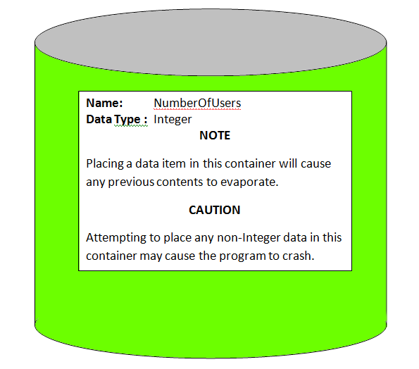

Where do I get variables?
You have to request them from the computer’s operating system. To do this, you need to include a line in your program called a declaration. In pseudocode, it is conventional to use the word Declare, providing the desired variable name and data type, such as
Declare NumberOfUsers as Integer

What are the available data types?
Most programming languages offer a wide variety of data types, and most languages offer you some capability to build your own types. In this class, we will only use the following five data types:
Integer: A variable of type Integer can contain any mathematical integer in the range from -2,147,483,648 to +2,147,483,647.
Float: A variable of type Float can contain numbers with decimal fraction parts as well as integer parts, such as 3.1416 or -275.1234. However, a Float is only good for about seven decimal places of precision.
Boolean: A variable of type Boolean can only store one of two values: TRUE or FALSE.
Character: A variable of type Character can store exactly one character, such as a letter, digit, punctuation mark, or space. In many programming languages, it is the convention to enclose a character in single quotes, such as 'A', 'f', '$', or ' ' (the latter indicating the space character). We will use this convention in this class. A variable of type character can also store some “non-printable” characters such as newline (“Enter” on your keyboard) or tab.
String: A variable of type String can contain a string of zero or more characters, for instance, a name, address, or telephone number. In many programming languages, it is the convention to enclose strings in double quotes, such as "Robert Frost", "1234 North 180th Street", or "206-338-5699", and we will follow this convention in this class. A string can have zero characters, in which case it is written as "".
I have some numbers to deal with. Should I use Integer or Float?
If you are counting something, such as users or horses or computers, use Integer. You can’t have a fractional part of a user.
If you are dealing with something that can be measured, such as a length or weight, use Float.
In our company, all our engineering drawings have drawing numbers. Should I use the Integer data type?
Have you ever added up the drawings numbers for all the drawings on some project? I don’t think so. If it doesn’t make sense to do arithmetic with it, it’s not a numeric value! Use String instead. (Some other “numbers” that are not really numbers include social security numbers and driver’s license numbers.)

